# Day 4: Booleans, logical operators and conditional statements

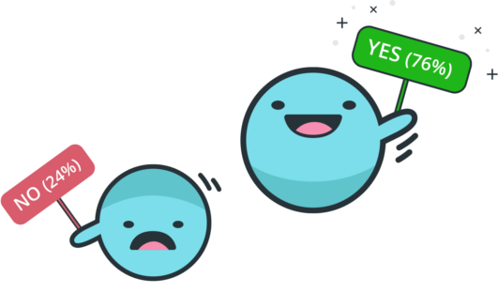

# Start the lab

* Open up a shell in idle 

# Part 1. Types Practice

Underline the right solution. Try typing it in the shell!  
(True and False are both the boolean, 'bool', type.)

|  |  |  |
| --- | --- | --- |
|  |  | **Underline One** |
|  | 10 == 11 | True or **False** or Error |
|  | 'strings'=="strings" | **True** or False or Error |
|  | 'strings'=="strings' | True or False or Error |
|  | B == 10 = 5 | True or False or Error |
|  | A = 10 == 10 | True or False or Error |
|  | (5 > 0) == False | True or False or Error |

## 

## Part 2. Boolean Operators (Comparing Magnitude and Equality)

Ted was typing in the Python shell. His screen is printed below, with some parts missing.

**Fill in the missing parts using ==, !=, >, <, >=, <=, or integers.**

*Check your answers in IDLE3. (There may be more than one correct answer!)*

|  |
| --- |
| >>> 6 _==_ 7  False  >>> 6___ >= -1  True  >>> 'MEET' ___ 'meet'  False  >>> "meet" !=___ 'meet'  True  >>> a = 3  >>> b = 10  >>> a*4 ___> 2*b  False |

## Part 3. Conditional statement (if, elif, else) Practice

**Open a new file and name it tab.py.**

**Try out the following code:**

|  |
| --- |
| **tab = False**  **if tab:**  **print('chocolate')**  **print('Tabs are cool!')** |

**When you run the file what gets printed to the screen?**

____________Error_____________________________________________________

**Change** tab **from** False **to** True**. Now, what gets printed to the screen?**

______________Error___________________________________________________

**Now change the code to this:**

|  |
| --- |
| **tab = False**  **if tab:**  **print('chocolate')**  **print('Tabs are cool!')** |

**When you run the file what gets printed to the screen?**

__________________________________________________________________________________________________________________________________________________

**What is the difference between the two codes?**

___________________________________________________________________________________________________________________________________________________________________________________________________________________________

**Do you feel comfortable about indentations and code blocks now?**

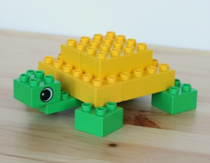

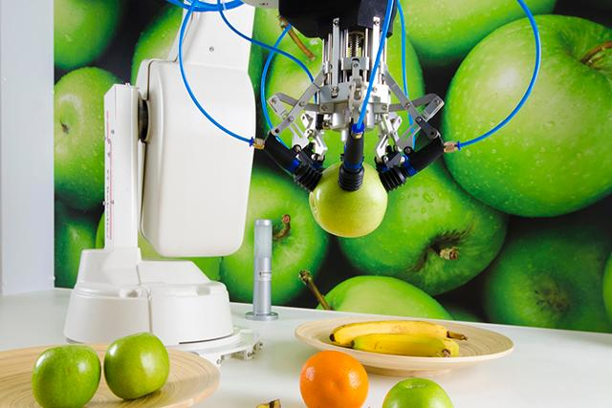

## Part 4. Fruit Sorter

**You are designing a fruit sorting robot for your local grocery store. Open a new file and name it fruit_sorter.py :**

* Takes in a kind of fruit as input from the user
* Assigns the fruit to the correct bin:
  + Apples in bin 1
  + Oranges in bin 2
  + Bananas in bin 3
* If the input is none of the above your code should print: 'Error! I do not recognize this fruit!'
* Make sure that your code accounts for

**If you get stuck look at the examples from today’s lecture!!!**

Here is what your code should look like when it runs:

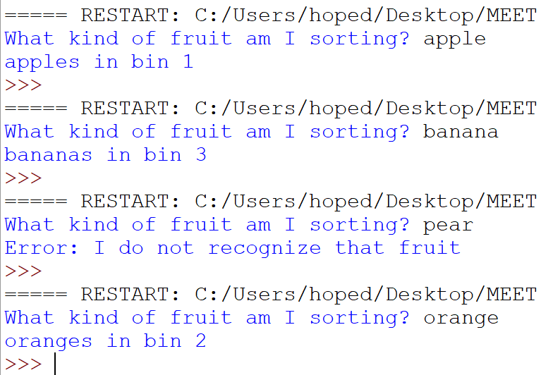

## Part 5: CodingBat

1. Go to <https://codingbat.com/python> and create an account.

**Remember:** On codingbat, you can test your code by hitting “Go”. You need to type “return” and then your answer or you will get an error!

**2.** Complete the following problems on codingbat!

**Turtle party: Go to** [**https://codingbat.com/prob/p250198**](https://codingbat.com/prob/p250198)

**Caught Speeding: Go to** [**https://codingbat.com/prob/p137202**](https://codingbat.com/prob/p137202)

## 

## 

## 

## 

## 

## 

## 

## 

## 

## 

## 

## 

## Part 6 Logic Comparisons

**Compare script_a.py and script_b.py:**

**script_a.py:**

|  |
| --- |
| **num1 = ____**  **num2 = ____**  **num3 = ____**  **if num1 > num2:**  **print('chocolate')**  **elif num1 > num3:**  **print('vanilla')**  **else:**  **print('strawberry')** |

**script_b.py:**

|  |
| --- |
| **num1 = ____**  **num2 = ____**  **num3 = ____**  **if num1 > num3:**  **print('chocolate')**  **elif num1 > num2:**  **print('vanilla')**  **else:**  **print('strawberry')** |

Do you think they should give the same answer when:

num1 = 2

num2 = 3

num3 = 1

Write your answer below and explain your reasoning.

Answer: _______________________________________________________________________________________________________________________________________________________________________________________________________________________________________________________________________________________________________________________________________________________________________________________________________________________________________________________________________________________________________________________________

Copy **script_a.py** and **script_b.py** into two Python files. Run each on those same assignments  
 (num1 = 2 num2 = 3 num3 = 1). Were you correct? Are the answers the same?

## Bonus:

[Complete the logic 1 codingbat problems](https://codingbat.com/python/Logic-1)

Don’t forget:

* Save your work using endlab

- [TO DO YOUR SURVEY](https://docs.google.com/forms/d/e/1FAIpQLSfW74wRscUTg2QtpScHQrrHLAEk86BKgphprOUBz-woGKXD7Q/viewform?usp=sf_link)